**ASSIGNMENT NO : 5**

1. Draw DFD(data flow diagram) for Third Eye project .

CONTEXT LEVEL DIAGRAM :

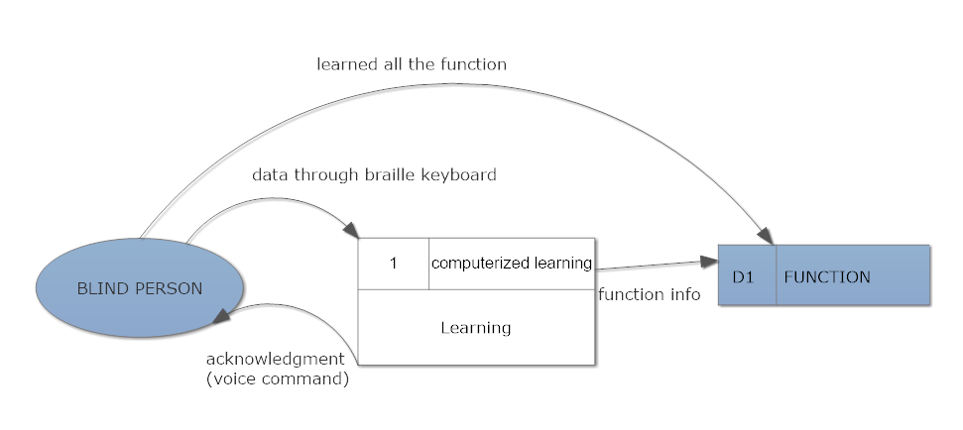

LEVEL 1 DFD :

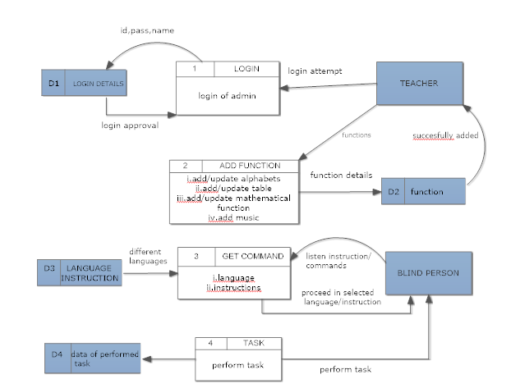

2.Transfer the DFD into structural chart

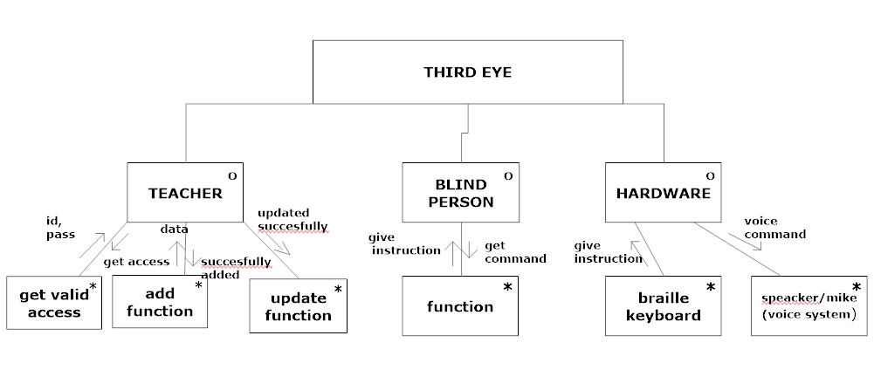

3.Identify all data stores from DFD

1. write data dictionary

ANS :

Teacher(TeacherID,name,password)

Blind _Person(name,id)

Function(tables,alphabets,mathematical function,music)

1. draw ER diagram

ER DIGRAM –THIRD EYE

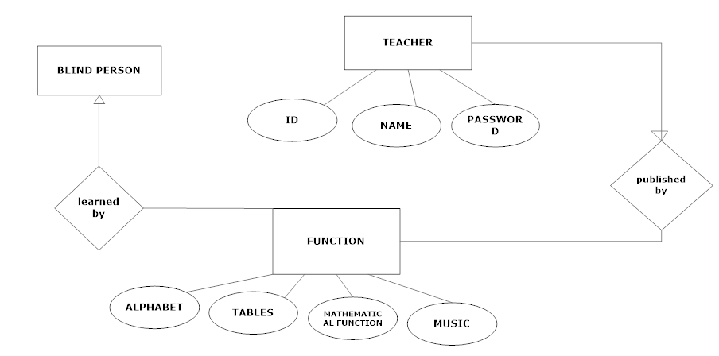

1. translate ER model to physical schema in sql .

ANS :

Teacher table -

create table teacher(id int(10),name varchar(25),password varchar(25))

|  |  |  |  |
| --- | --- | --- | --- |
| Sr.no | Field name | Data type | size |
| 1 | id | int | 10 |
| 2 | Name | Varchar | 25 |
| 3 | Password | varchar | 25 |

Function table –

create table function(alphabets char(250),tables int(250),mathematical_function varchar(250),music varchar(250))

|  |  |  |  |
| --- | --- | --- | --- |
| Sr.no | Field name | Data type | Size |
| 1 | Alphabets | char | 250 |
| 2 | Tales | Int | 250 |
| 3 | Mathematica_function | Varchar | 250 |
| 4 | Music | Varchar | 250 |